Grade Item Reflection Worksheet
For Data Based Teacher Reflection
Ms. Dickson’s Class
Teaching English on a Shoestring Budget
http://www.teacherspayteachers.com/Store/Msdickson

Overview:
A tool to organize and reflect on gradebook data at the end of the term. It includes options to plug in and review data from the gradebook, plus space to reflect on possible implications and applications.

Teacher Notes:
Data-based analysis is a trending topic in education. It doesn’t have to be complicated or time-consuming. Even selecting a couple data points for analysis and reflection can help guide teaching practices towards improved outcomes. Plus, it’s good, concrete evidence for teacher portfolios.

Reflection considerations: Is it a student issue or an assignment issue? Was it a difficult text? Trouble understanding one or more parts of the assignment requirements? Were there extenuating circumstances: Substitute teacher, disrupted schedule such as with snow days, or other interruption? Was it a one-off you tried and something didn’t work out (if so, consider choosing another assignment that more appropriately reflects the normal type of work assigned.) Would additional time or student support overcome the issues? Should the assignment be revised, broken into scaffolded parts, or scrapped? You may even decide not to revise this time, but to give it another try before overhaul. Maybe you or the students had an off day.
Regardless of what you reveal, the important thing is to look at the data (gradebook values) and reflect on what happened, and why in a way that is honest and fair to yourself and your students.

Least Successful Grade Item Reflection
Grade Item with the LEAST successful student submissions:

Students in class:
Successful submissions:
Percent:

What possible difficulties did students have?

In reviewing successful submissions, what items/ parts had the lowest success rate?

What makes this assignment different from a similar, more successful assignment?
What can be done to revise the assignment OR the support for next time?

Most Successful Grade Item Reflection
Grade Item with the MOST successful student submissions:

Students in class:
Successful submissions:
Percent:

What parts did students do best on?

What factors may have contributed to engagement, comprehension, & success?

What makes this assignment different from a similar, less successful assignment?
What can be done to revise the assignment OR the support for next time?

Grade Item Reflection
Grade Item:

Students in class:
Successful submissions:
Percent:

Reflections on success or struggles

Compare to other assignments
Future Revisions

Thanks for Buying!
If you enjoyed this item, check out my store: High School English on a Shoestring Budget. I use free eTexts and creative, multi-day projects to stretch my shoestring budget and now you can use these resources to stretch your budget!

Check these out:

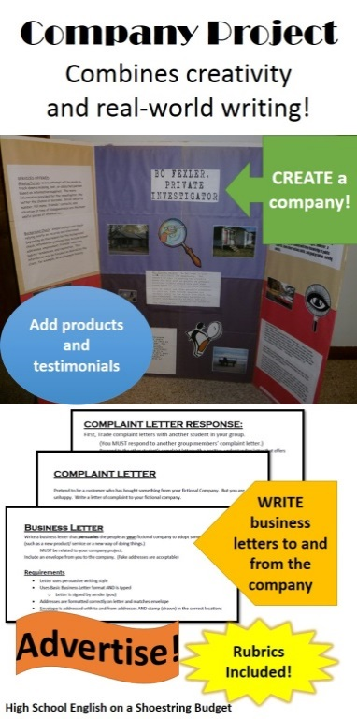 | 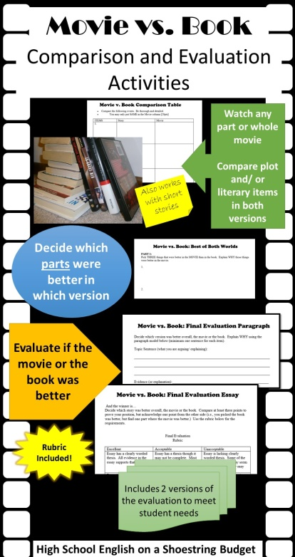 | 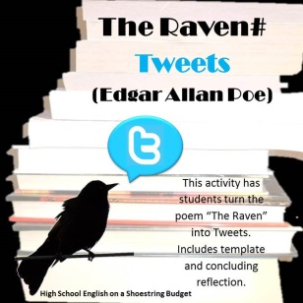 | Activity Bundles currently available for the following:  - The Raven  - The Cask of Amontillado  - Legend of Sleepy Hollow  - A Christmas Carol  - MLK’s “I Have a Dream” speech  - Rip Van Winkle  - The Metamorphosis  - Aladdin  - The Monkey’s Paw  - The Time Machine  - Frankenstein  - The Call of the Wild  - Snow Poetry Activity Bundle (Frost, Dickinson, Emerson)  - After Twenty Years  - The Necklace  - Bundle Contents also sold individually  - And more coming soon!
 |  | 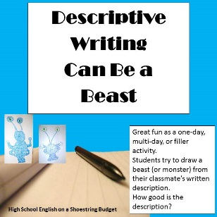
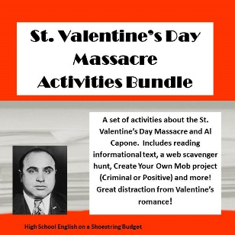 | 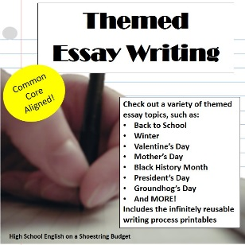  Many different essay themes available! | 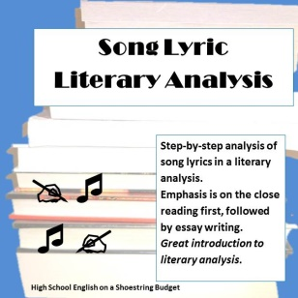
High School English on a Shoestring Budget
Ms. Dickson’s Class

Remember, leaving feedback can earn you TPT credits towards your next purchase!

I'm also on Pinterest: http://www.pinterest.com/asleepatmouse/high-school-english-on-a-shoestring-budget/ And Facebook: https://www.facebook.com/msdicksontpt

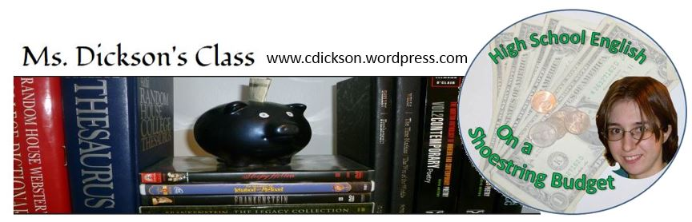
Visit my blog:

Copyright Information
Short version: please respect my time and copyright by sharing a link to my store or purchasing additional licenses at a reduced cost.

Legal stuff: This is a paid digital download from my Teachers Pay Teachers Store: http://www.teacherspayteachers.com/Store/Msdickson

As such, it is for use in one classroom only. (You may purchase additional licenses at a reduced cost).
This item is also bound by copyright laws and redistributing, editing, selling, or posting this item (or any part thereof) on the internet are all strictly prohibited without first gaining permission from the author. This includes posting on a class website that is open to the public (i.e. no password or restricted access.) Items sold as “Fully Editable” include permission to edit for classroom use.

Violations are subject to the penalties of the Digital Millennium Copyright Act. Please contact me with questions. msdickson.tpt@gmail.com

